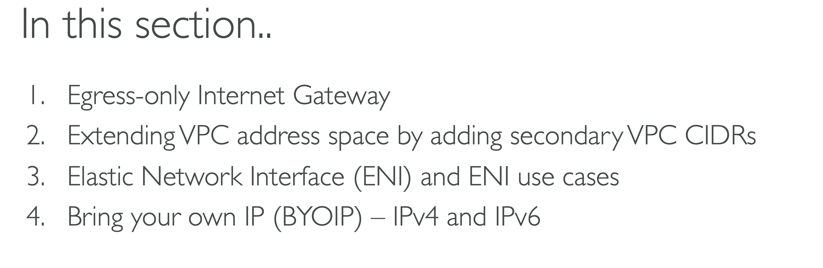

Egress Only

NAT GW does not support IPv6 traffic to IPv6 traffic

::/0 -> All IPv6 addresses

In your VPC you can have both IGW and Egress only Internet Gateway.

So in the earlier section that is VPC fundamentals. We talked about AWS managed Nat gateways, which allows the internet access to the instances in the private subnets and in that case the traffic goes something like this where you have the VPC and then you have the route table for the public subnet where the traffic goes to the internet through the IGW and in the public subnet you have the Nat gateway which has the public IP or the elastic IP managed by AWS and then in the private subnet you have EC2 instance and in the route table you says that all the internet traffic should go through this Nat gateway. So this is IPv4 to IPv4 traffic.

That means the source is IPv4 address and the destination is also the IPv4 address.

And in that case Nat gateway is useful.

But as you know VPC also support IPv6 traffic and it supports dual stack mode where you could have the subnets which are IPv4 only, or dual stack

or IPv6 only subnet. Also, you know, IPv6 addresses are public by default.

But what if you need EC2 instances with IPv6 IP address to remain private inside your private subnet.

So now let's say we also have a VPC with IPv6 addresses.

And from this instance we want to reach to IPv6 address on the internet.

And in that case we also will have the VPC CIDR range for IPv6 and same for the subnet and which means this instance will also have IPv6 address.

And in that case the route tables for this subnet will be something like this where there will be additional route for the VPC IPv6 CIDR range and the target will be local.

And similarly for the private subnet there will be this route.

Now if you see this setup, if you want to communicate using IPv6 address from this instance to this particular IPv6 address on the internet, the traffic cannot go through the Nat gateway because Nat gateway does not support IPv6 to IPv6 traffic.

Now, if you want this communication to happen, you would have to put this instance in the public subnet. But you don't want that. You want similar behaviour that you get with IPv4 address.

Right.

So what do you do?

Now for that AWS also supports something called egress only internet gateway.

Which means it only supports the egress traffic.

That means the outbound traffic from the VPC to the internet, and it doesn't allow outside hosts to communicate directly to your IPv6 address inside the VPC.

So basically you create another internet gateway but of type egress only.

And then you have to modify the route table for the private subnet.

And there you say if the traffic is going to colon colon slash zero which is all IPv6 addresses then it should go through egress only Internet gateway.

And now from this host, if you try to go to the internet over IPv6 address then traffic will go something like this.

So that is what egress only internet gateway is. So for your VPC you can have both internet gateway and egress only internet gateway as well.

So that's about egress only internet gateway which is used for host IPv6 addresses to communicate outside similar to the Nat.

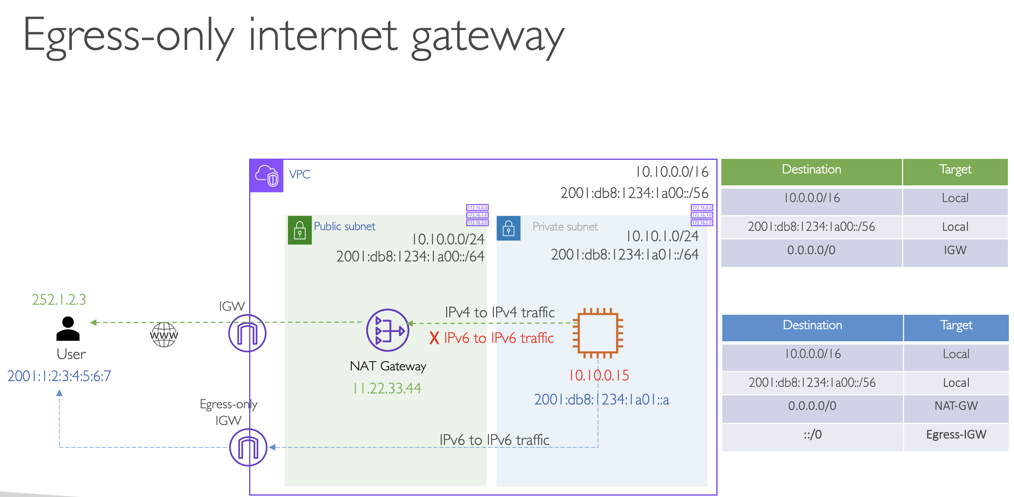

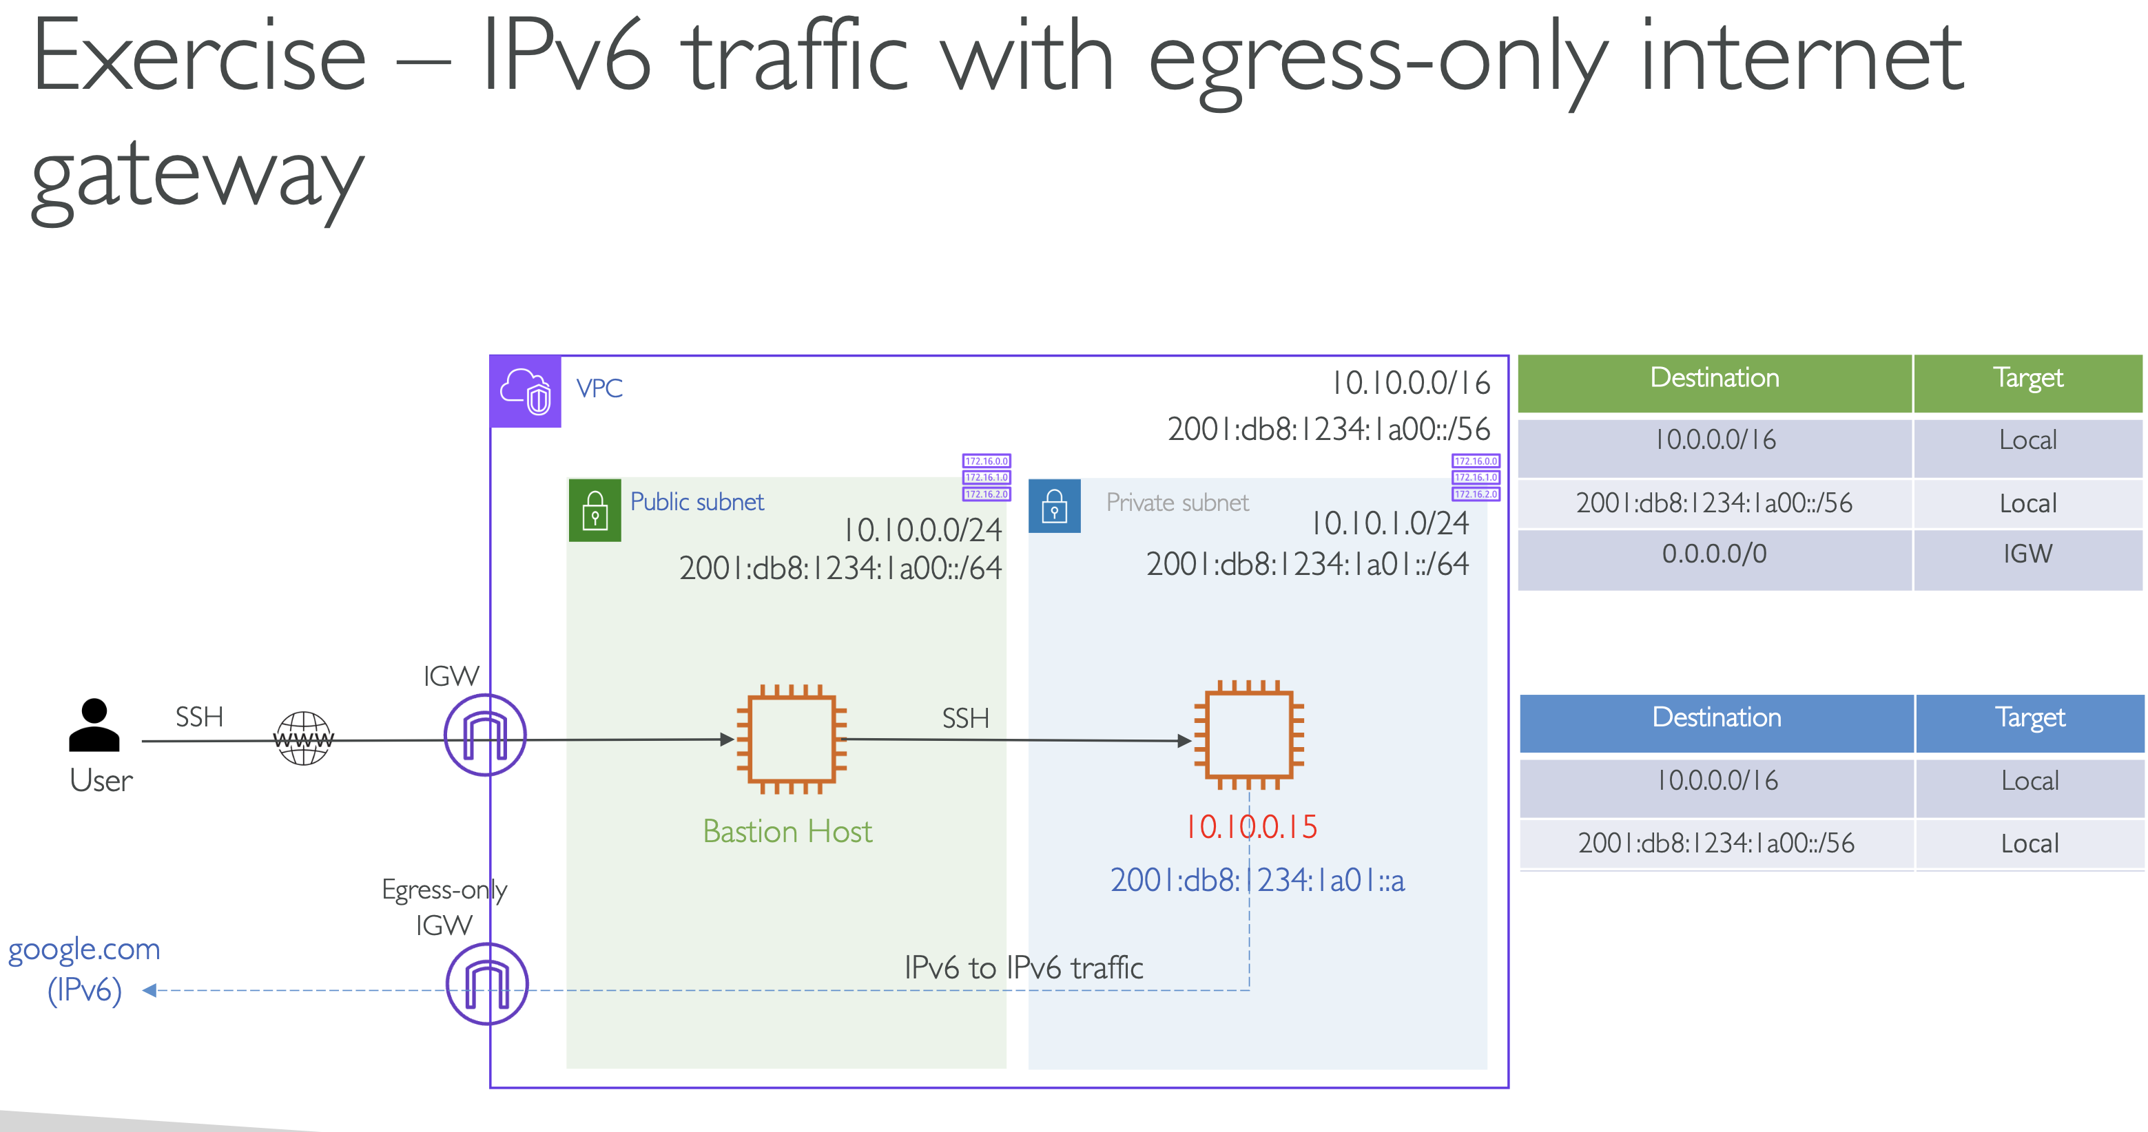

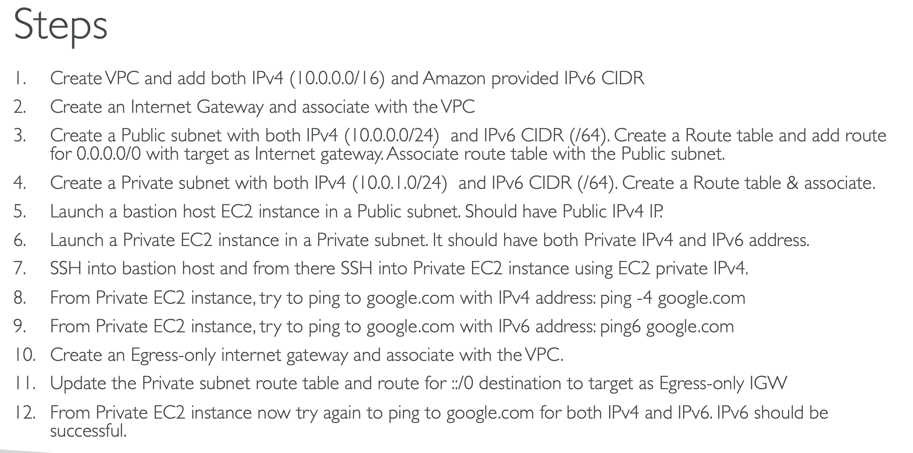

Extending VPC address space

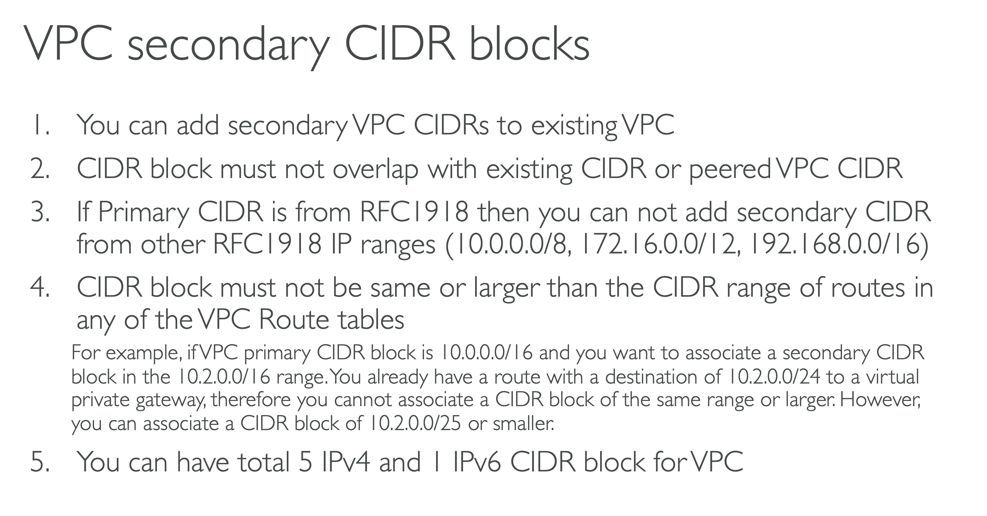

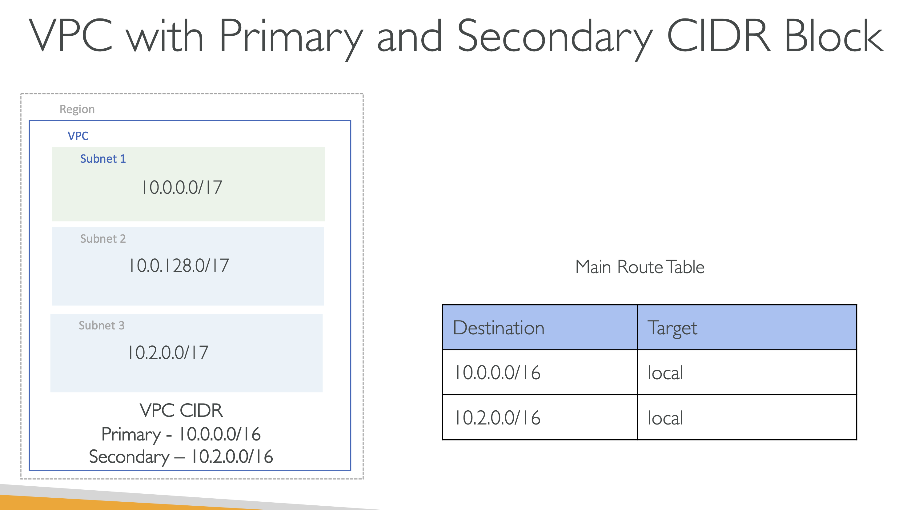

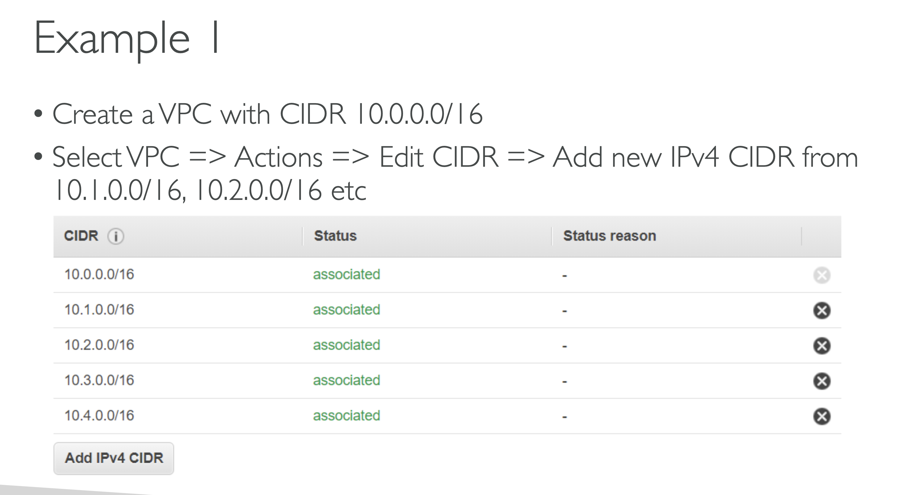

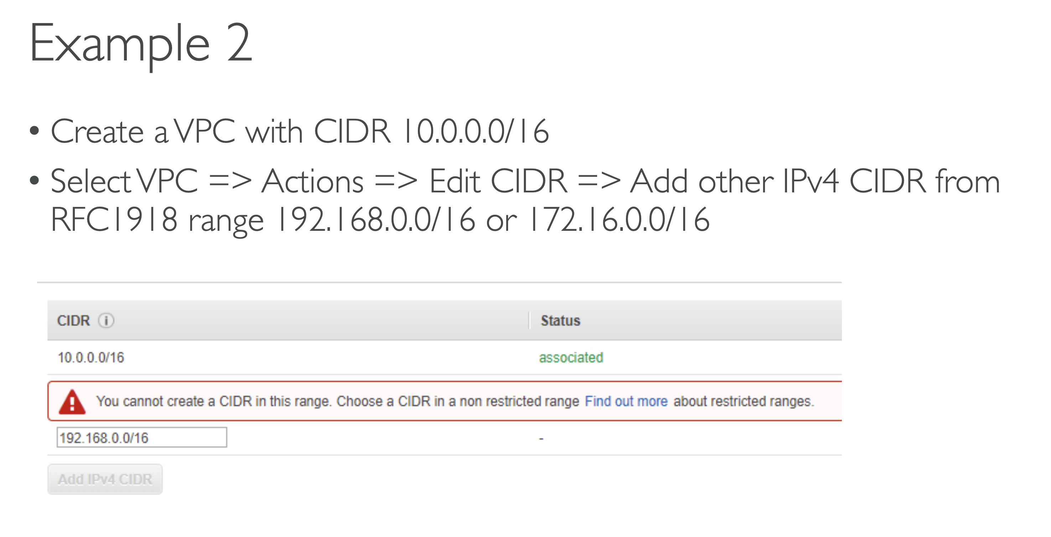

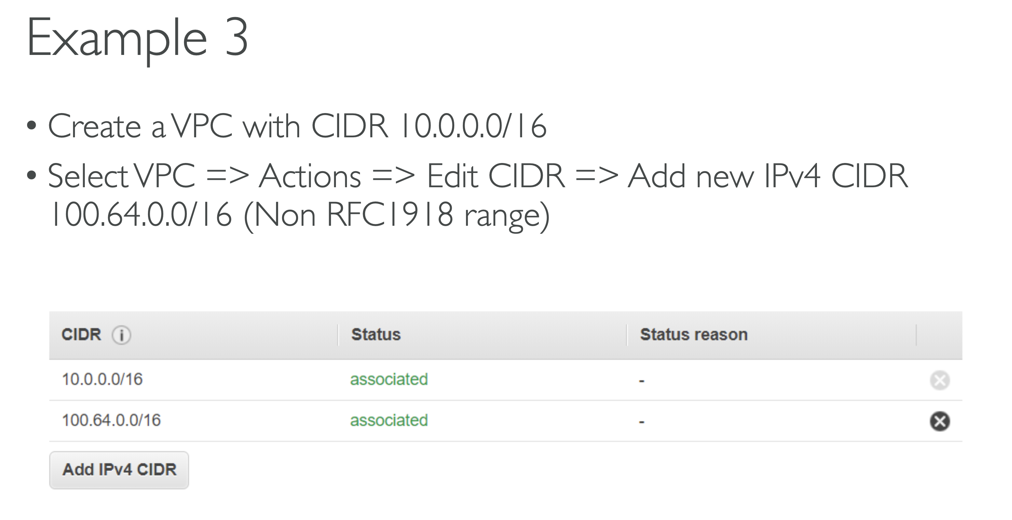

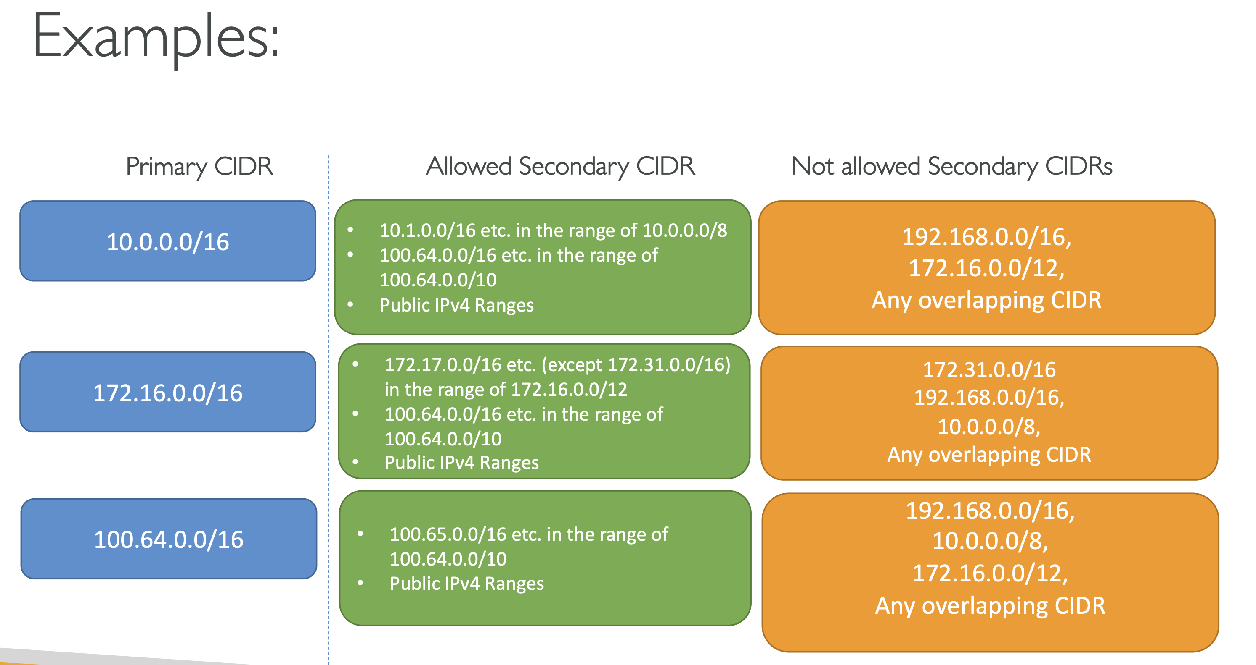

ENI : Elastic Network Interface

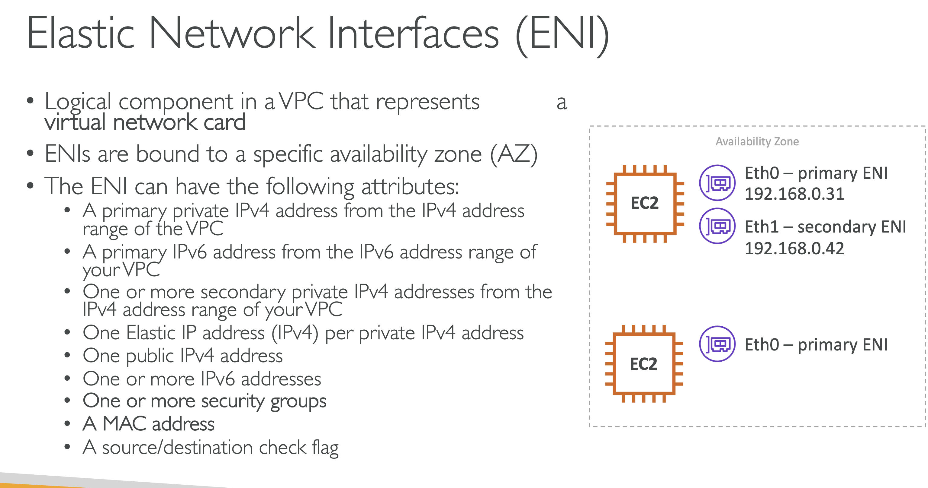

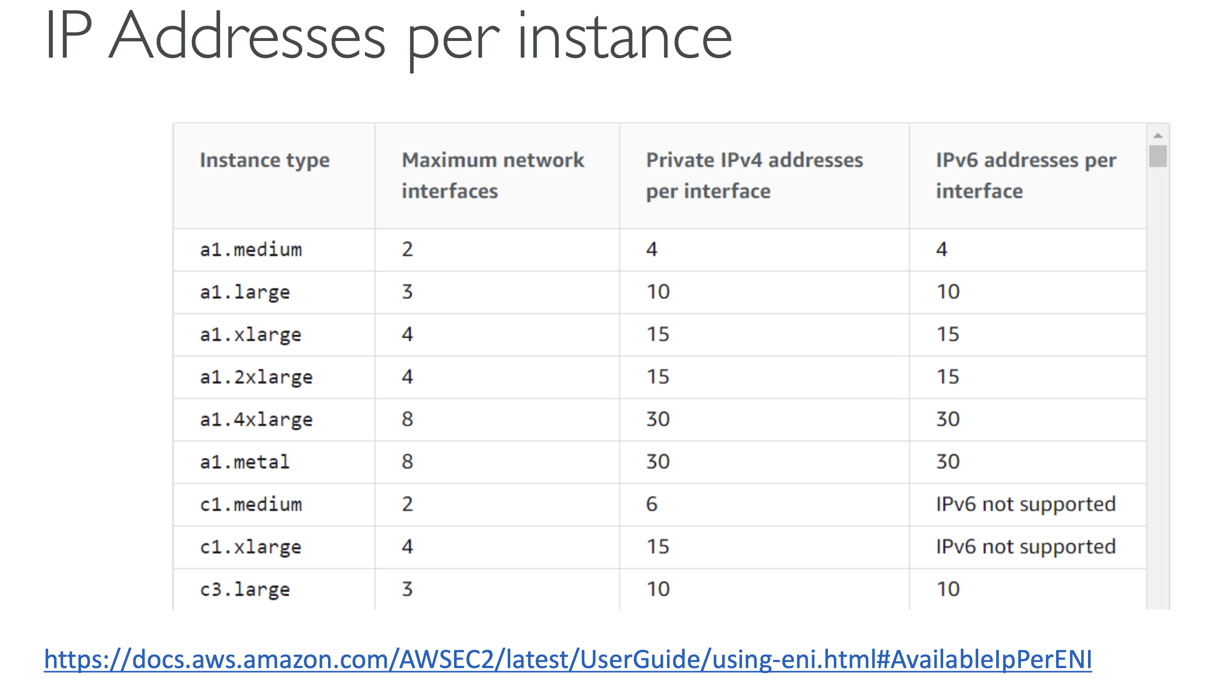

Now if you remember in the Nat exercise where we had configured Nat on the EC2 instance, we had disabled the source destination check and in that case we actually disabled that on the Eni of that EC2 instance. So that feature actually comes from the Eni and because the Inis can be attached and detached from the EC2 instance and we are talking about the secondary Eni, then you can definitely detach that secondary Eni from one EC2 instance and can attach to another EC2 instance.

Now you can't do that with the primary ENIs because that's primary.

But definitely you can do that with the secondary ENIs.

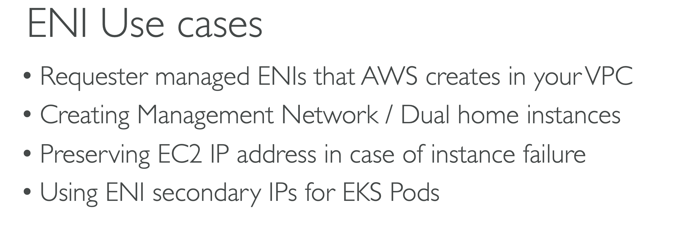

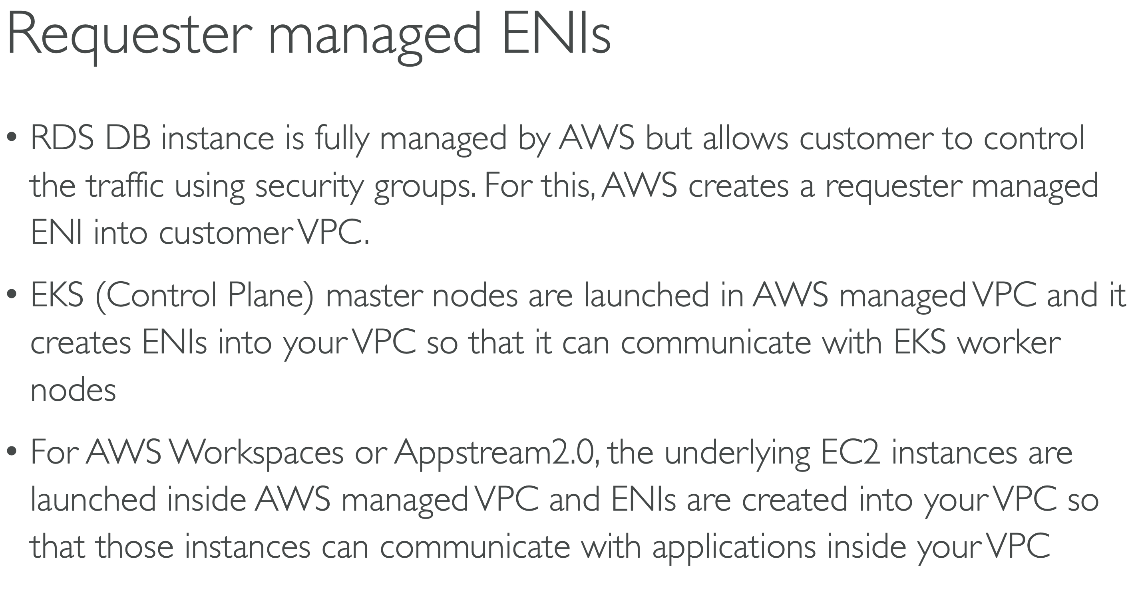

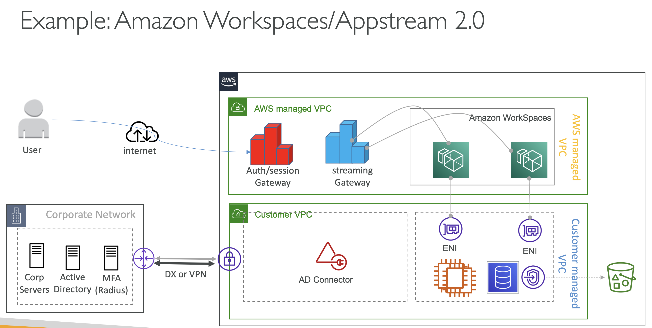

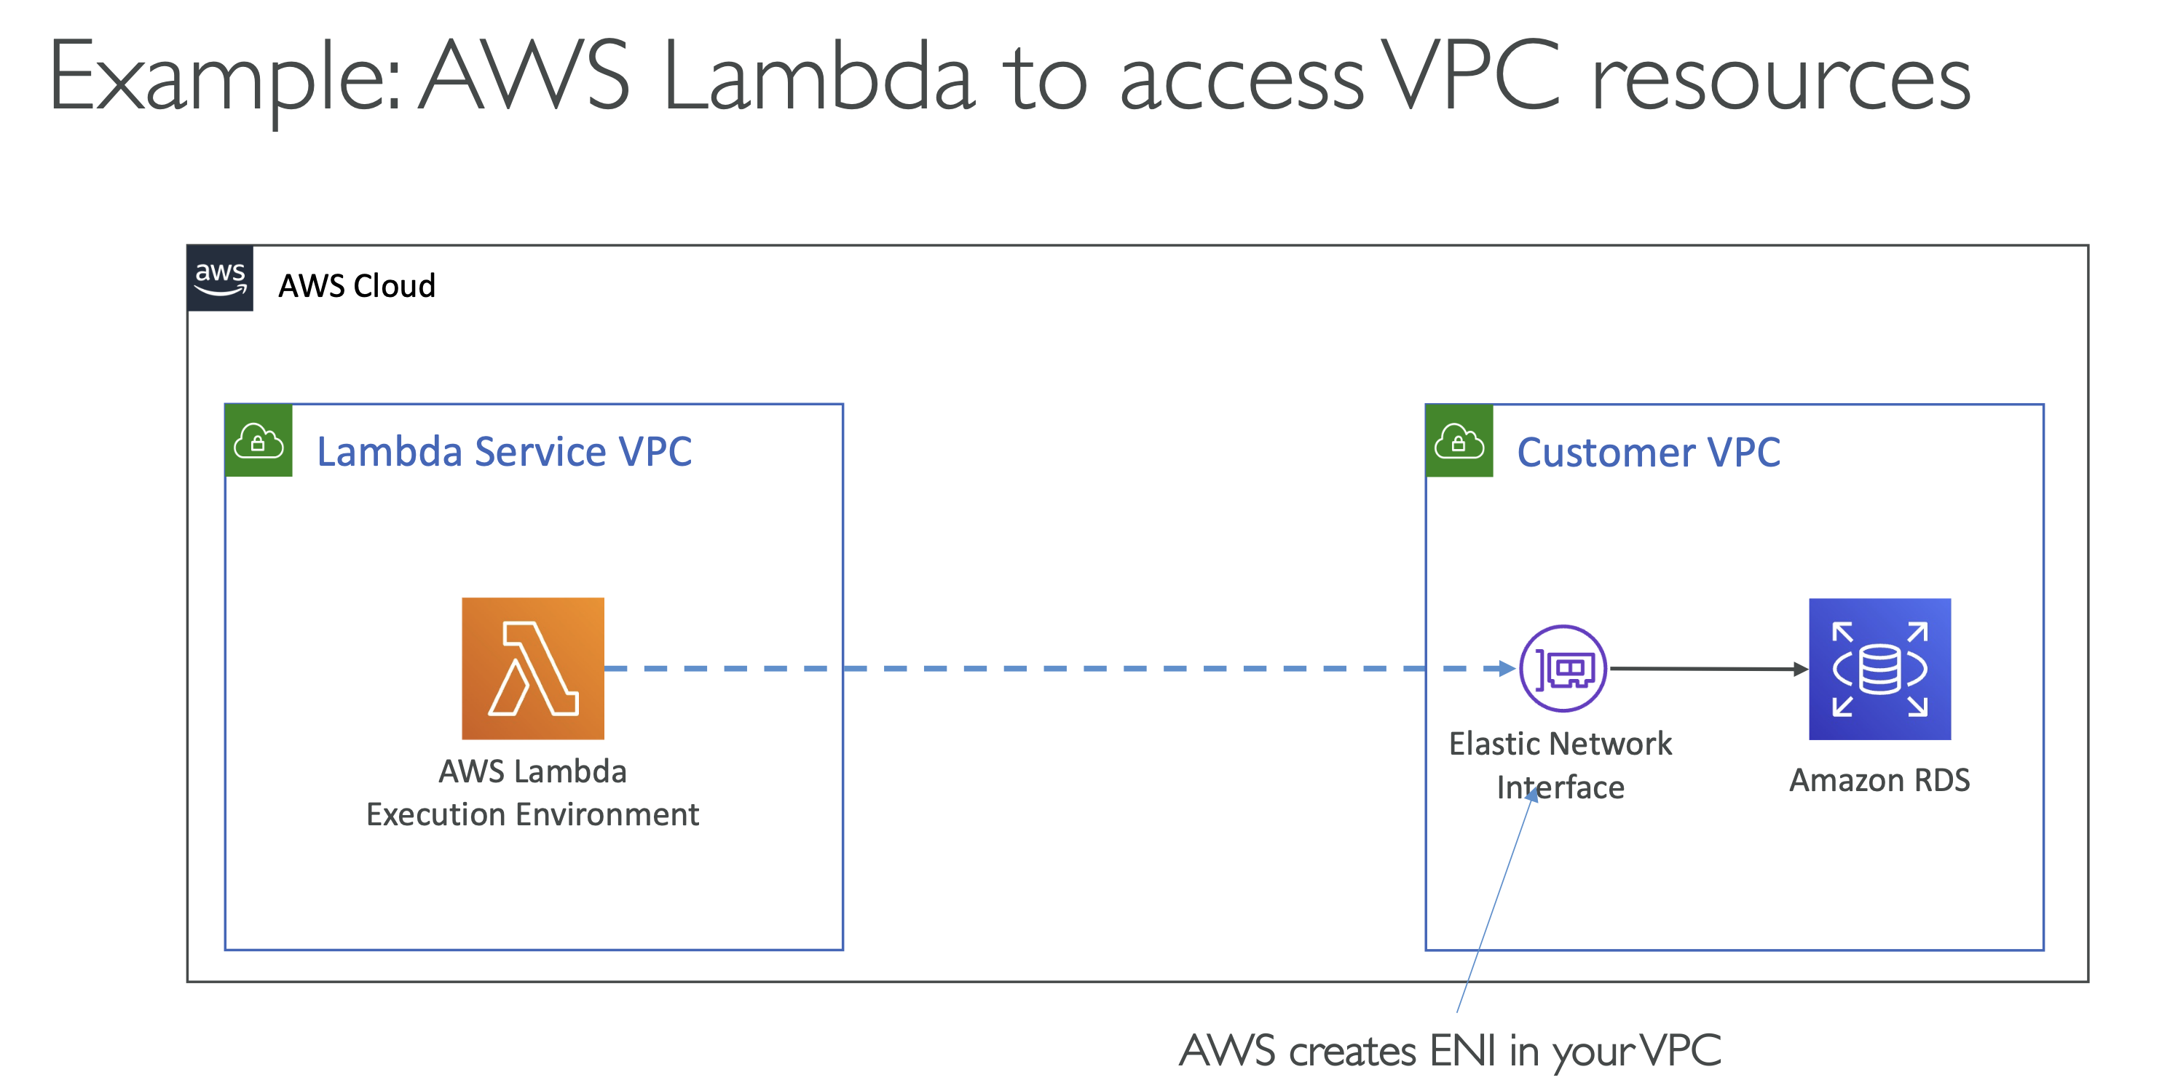

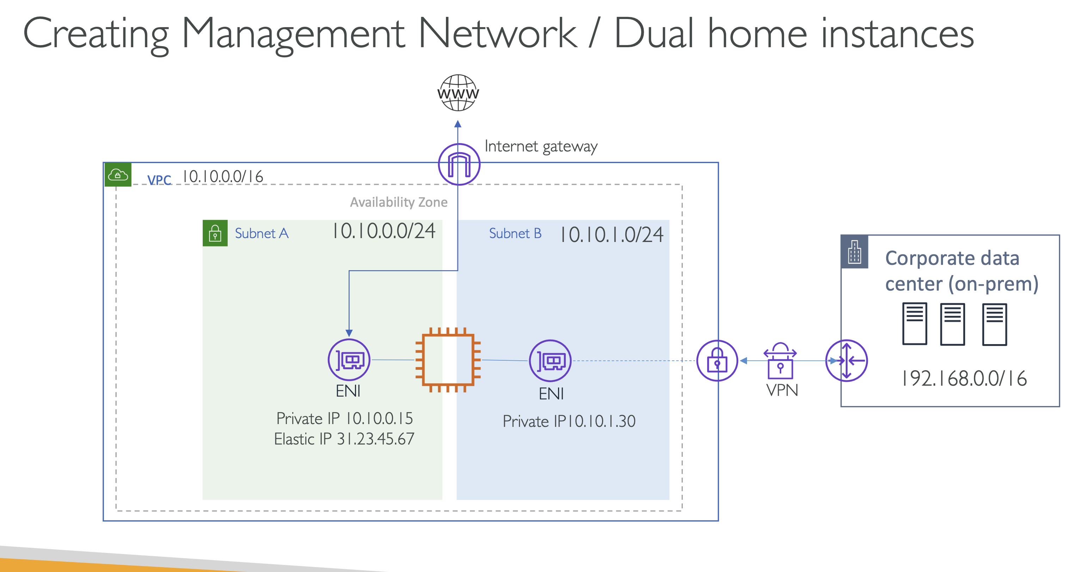

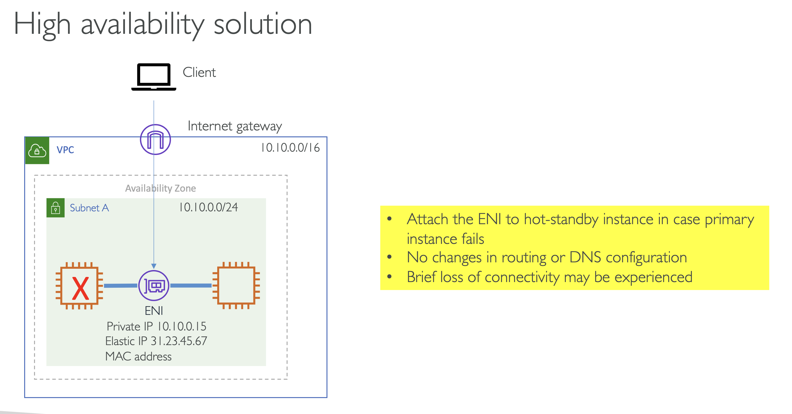

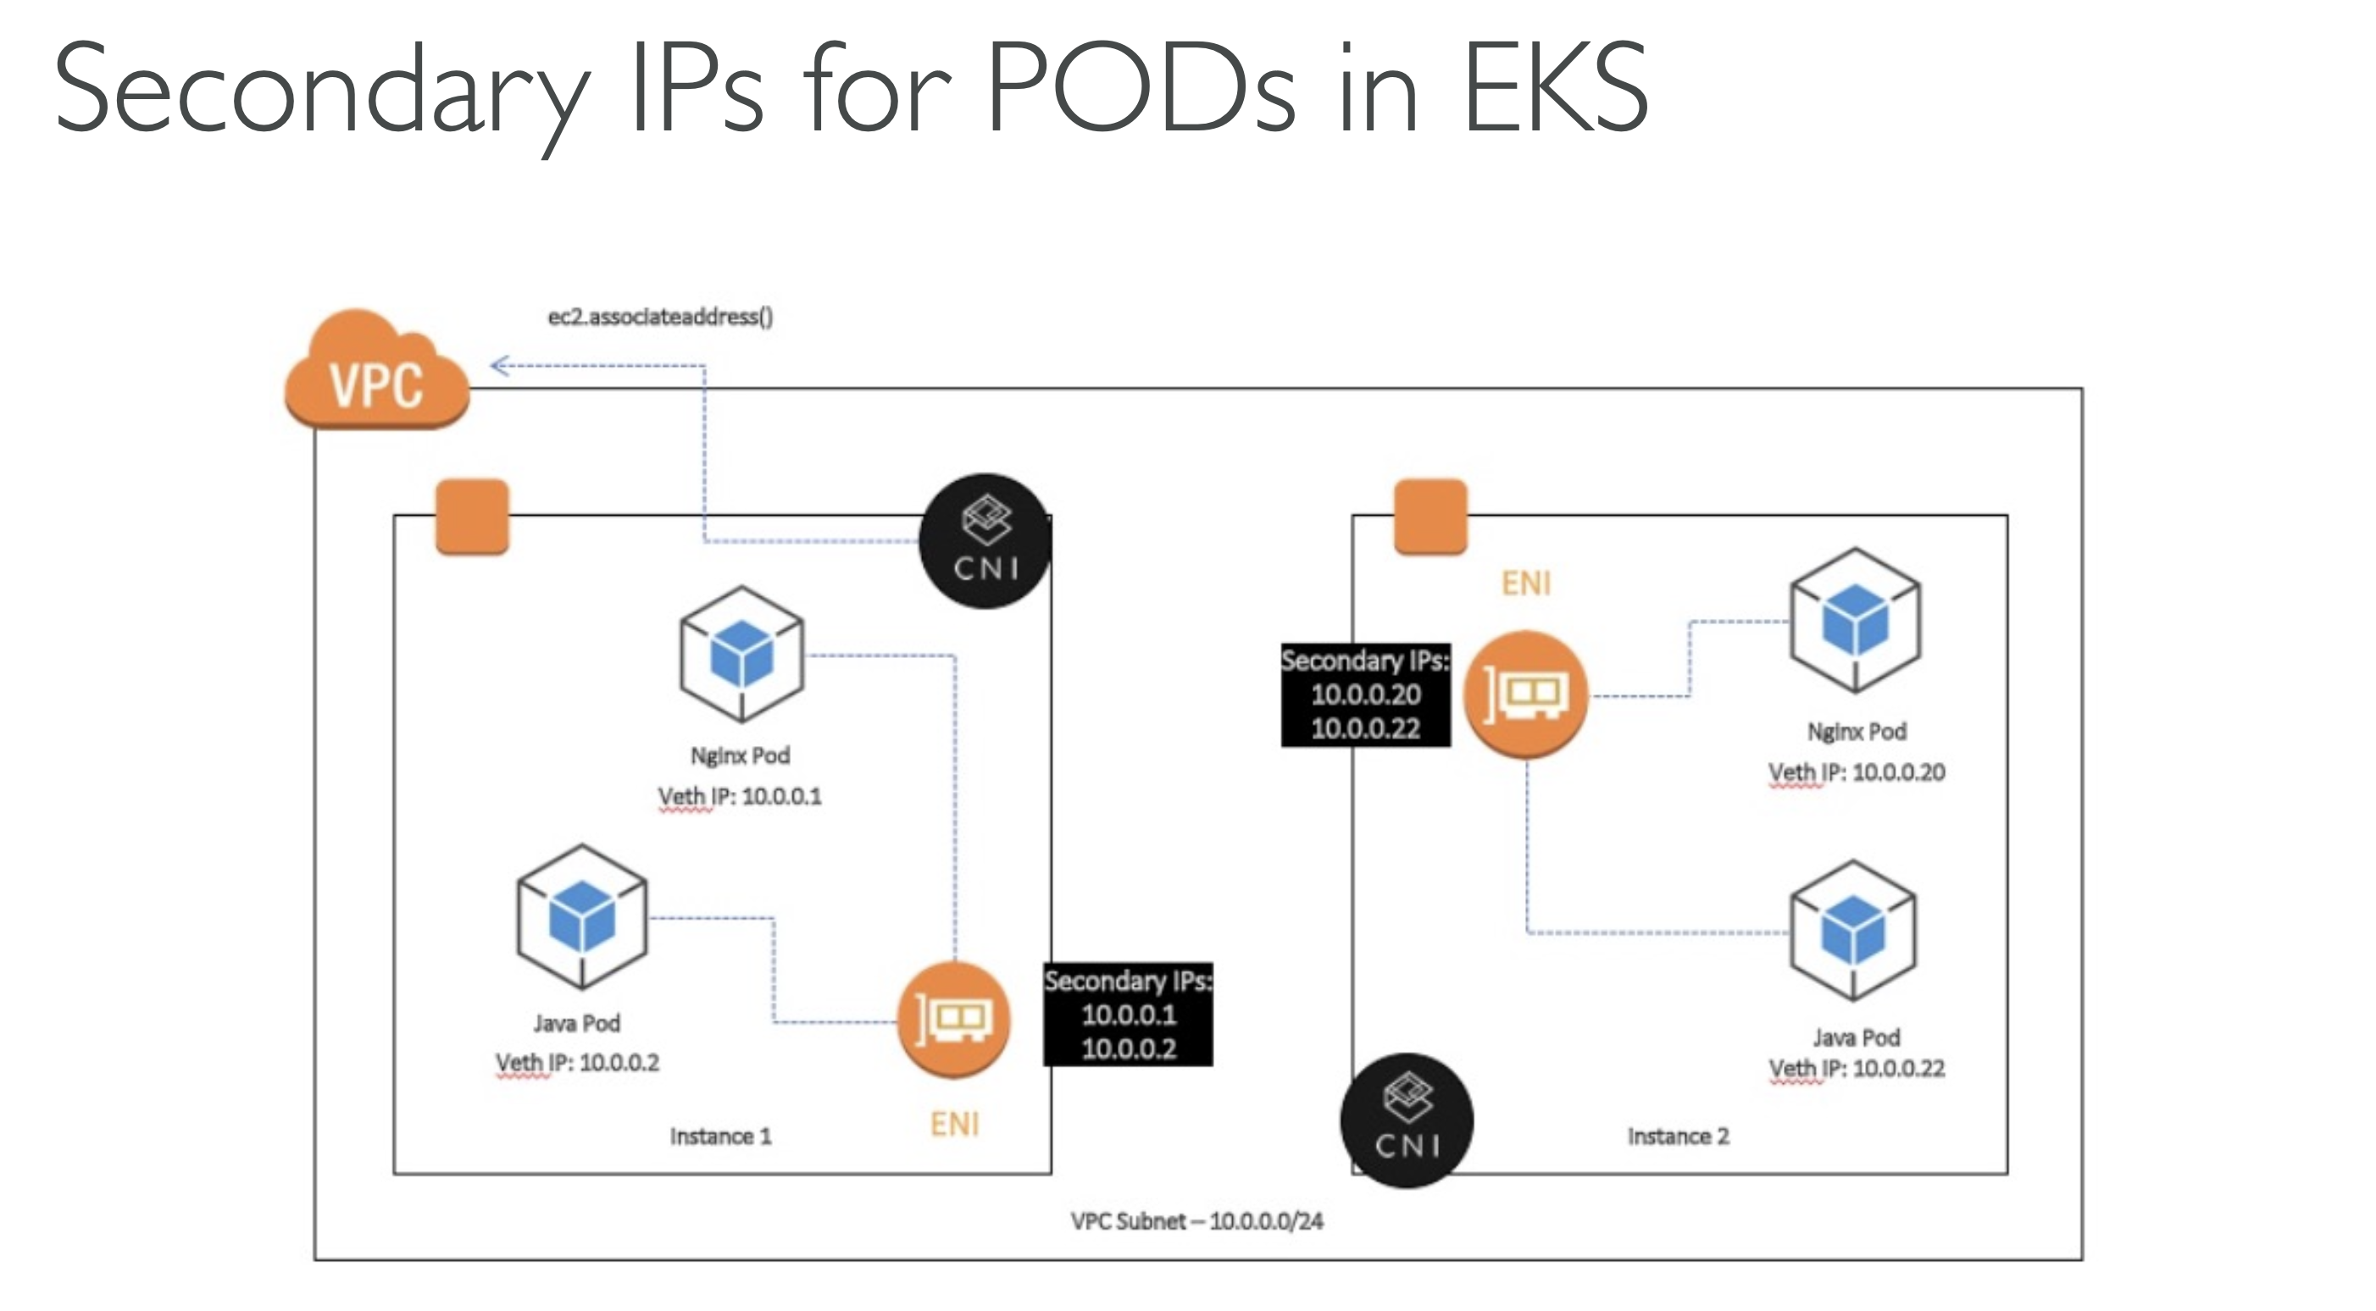

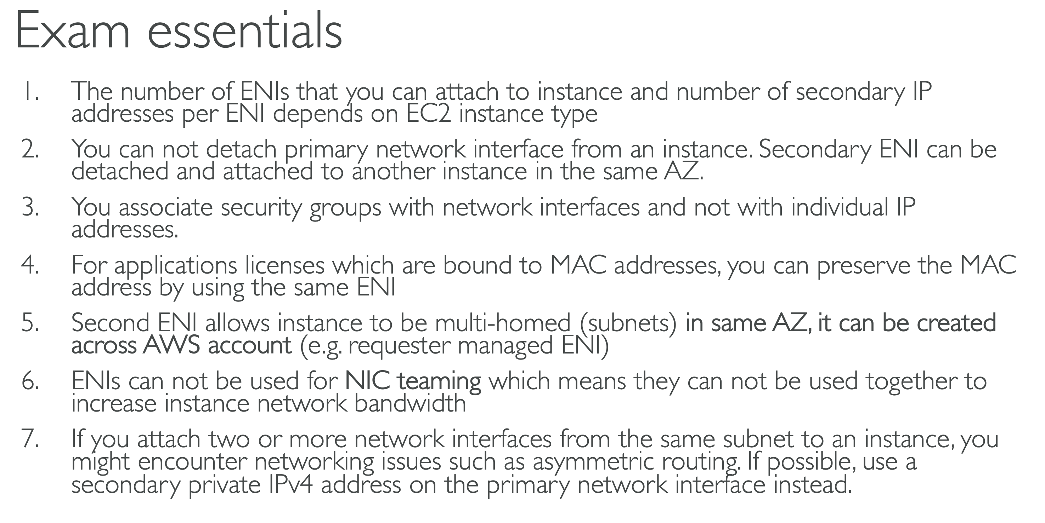

BRING YOUR OWN IP

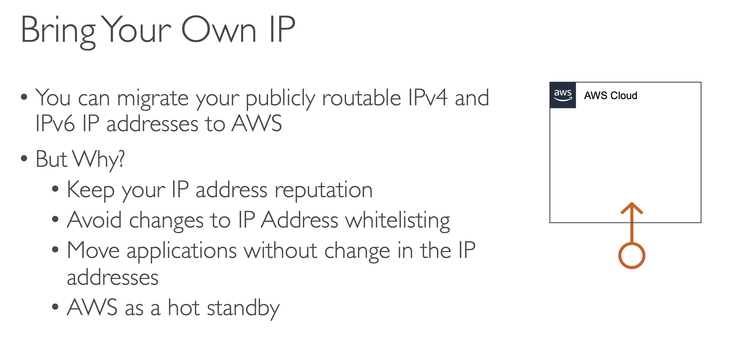

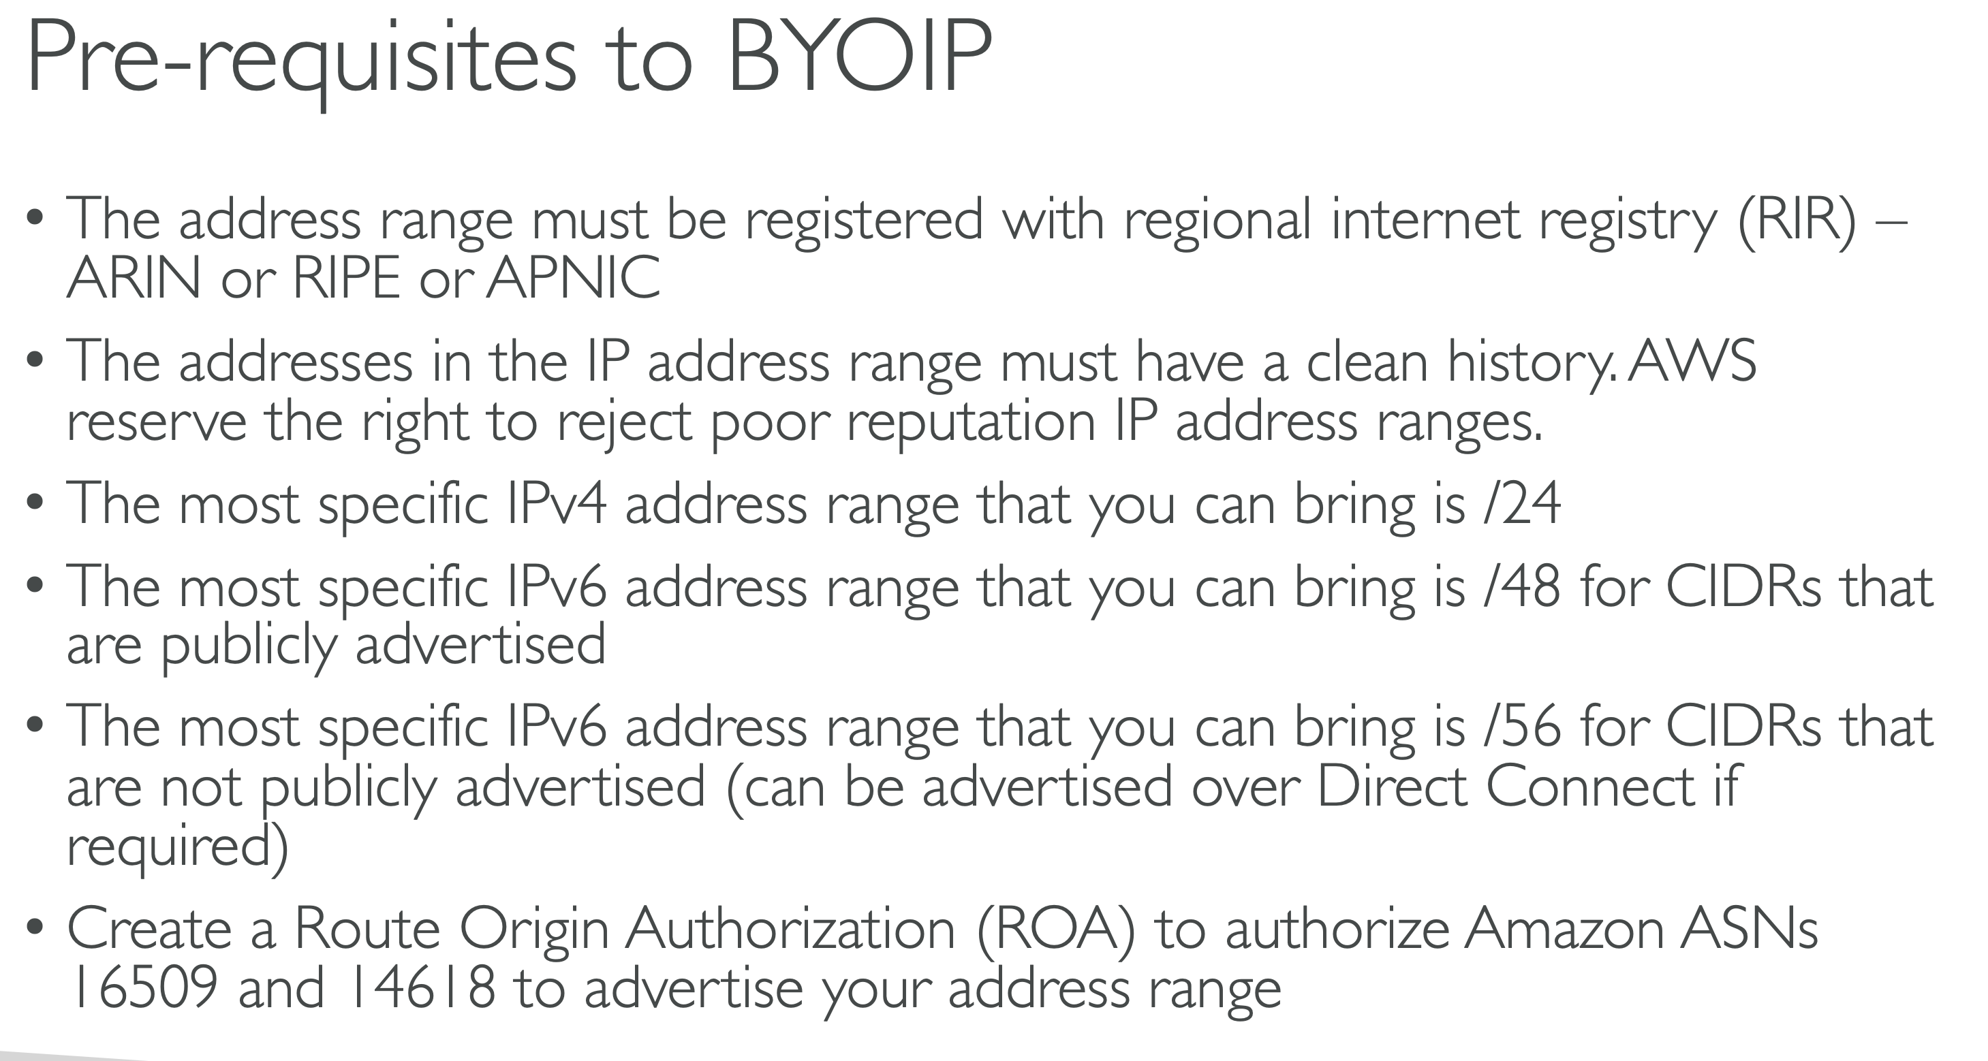

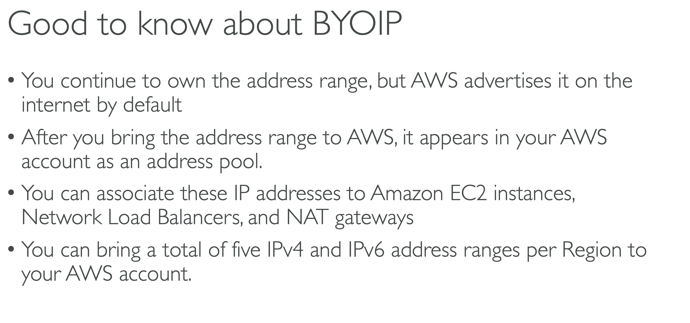

Top of Form

Bottom of Form

Top of Form

Bottom of Form